Cẩm nang
Happy Meeting

YND MELBOURNE 2014
The Sebel & Citigate Albert Park
Melbourne, Australia
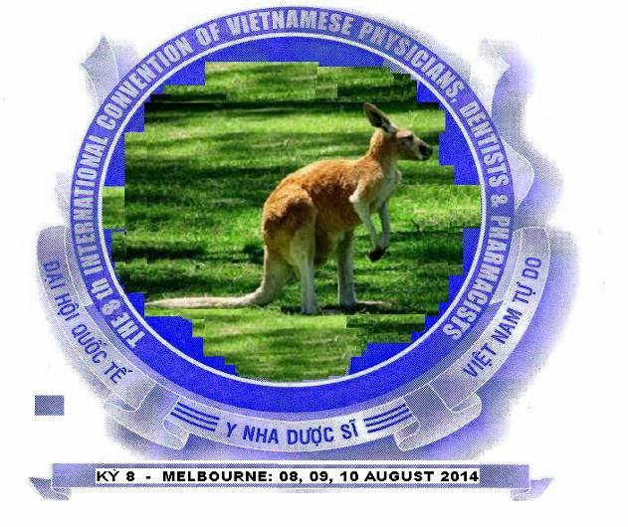

August 8,9,10/ 2014
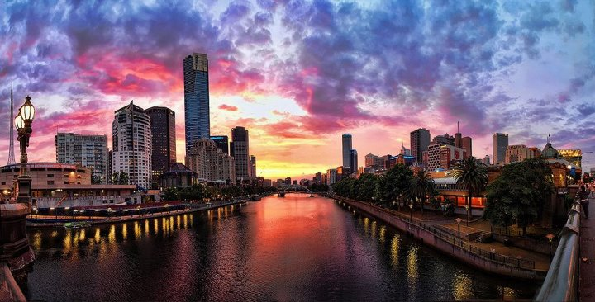
The 8th International Convention of the Vietnamese Physicians, Dentists and Pharmacists of the Free World
Đại Hội Quốc Tế Y Nha Dược Sĩ
Việt Nam Tự Do kỳ thứ VIII 2014
The 8th International Convention of the Vietnamese Physicians,Dentists and
Pharmacists of the Free World.

The Australian Vietnamese Health Professionals Association of Victoria Inc
(ABN: 36-818-812-404)

01/05/2012

Dear Colleagues and Friends,

Welcome to The 8th IC VPDP YND 2014, in Melbourne, Victoria, Australia! The conference will be running on the following days: 8th, 9th and 10th of August 2014.

This conference is especially designed for General Practitioners, Specialists, Dentists, Pharmacists, Trainees and Allied Health Professionals. We are very honoured to have an excellent line up of guest speakers from all around the world who will present the most up-to-date information on current issues in Medicine, Dentistry and Pharmacy. A wide range of topics will be covered throughout the conference including cardiology, endocrinology, gastro-enterology, respiratory, infectious diseases, pain management, ophthalmology, obstetrics & gynecology, pediatrics and surgery.

The CME Program offers engaging lectures such as nutritional management of critically ill patients, new developments in oncological surgery and ambulatory care which can be used in large institutions, as well as public health issues for those in a community setting. Throughout the course there will be a focus on interaction and individualized attention with the opportunity to advance knowledge and skills in different fields.

Not only valuable in the academic domain, the convention includes the Art Exhibition, Ceremonies, Gala and Reunion Dinners to help you to expand your knowledge on the kingdom of kangaroos. The charms of a cosmopolitan Melbourne and the perfect blend of Queen Victorian style will surely amaze you. Some of the typical sceneries in Melbourne that you will able to visit are: Port Phillip, Great Ocean Road (Twelve Apostles), etc.

Besides that, joining the 2014 International Conventional will also give you a chance to visit other wonderful places in other Australia states, for example: Sydney Opera House, Canberra Parliament House, Uluru Alice Spring, Great Barrier Reef, etc.

We would like to express our gratitude to all the committee members for their hard work in planning this program. We are looking forward to seeing you here.

We hope you will find every minute here enjoyable. Are you ready to explore the alluring Melbourne?

On the behalf of the Scientific Program Planning Committee,

Dr. Pham Phuc Nhan

PRELIMINARY
SCIENTIFIC PROGRAM

Speakers TBA

Timetable e.g. Day 1 & Day 2:

8.25 – 8.30am Welcome/Opening Remarks

Session One
Chair - TBA
8.30-8.55
8.55-9.20
9.20-9.45
9.45-10 Panel Discussion

Break/Morning Tea
10-10.20

Session Two
Chair – TBA
10.20-10.45
10.45-11.10
11.10-11.35
11.35-12.00
12.00-12.10 Panel Discussion

Lunch 12.15-1pm

Session Three
1-1.25
1.25-150
1.50-2.15
2.15-2.40
2.40-3 Panel Discussion

Close of Session

Potential Topics
Women’s Health Session
Cervical Cancer screening / vaccination (Dr. Le Thao & Dr. Tran Hong)
Breast Lumps – Assessment & management (Mr. Binh)
Antenatal Screening (Dr. Le Thao)
Subfertility & In Vitro Fertilisation (Dr. Tran Hong)

Men’s Health Session
Erectile dysfunction (Mr. Pham Trung)
Update on prostate disease (Mr. Pham Trung)
Health prevention – smoking & alcohol
Depression (Dr. Pham Hieu)

Cardiovascular Disease Session
Current management of IHD (Dr. Nguyen Quy)
What’s new in atrial fibrillation (Dr. Nguyen Quy)
Congestive cardiac failure (Dr. Nguyen Quy)

Neoplasia Session
Cancer Screening
Surgical advances in the management of malignancies of the GI tract (Mr. Duong Cuong)
Targeted medical therapy in oncology (Prof. Le Brian)
Pain management and palliative care

Gastroenterology Session : (Dr. Nguyen Tin, Dr. Quach Thai & Dr. Le Huan)
Update on viral hepatitis B & C
Alcoholic liver disease
Hepatocellular carcinoma
Management of chronic liver disease

Miscellaneous
Obstructive Sleep Apnoea and Asthma (Dr. Tran Hoan)
Surgical management of obesity (Mr. Bui Hai)
Childhood asthma
Thyroid nodules / thyroid disease (Dr. Tran Jane)
COPD (Dr. Tran Hoan)
Up to date of Diabetes (Dr. Tran Jane)
Basic fracture and pain management (Mr. Thai Duy)
Common Skin diseases in General practice (Dr. Tran Diana)
Up to date of Osteoporosis

Thư mời

Kính thưa : Quý Niên Trưởng,
Quý Giáo Sư,
Quý Đồng Nghiệp Y Nha Dược ,
Quý Thân Hữu và Quan Khách ,

Để tiếp tục duy trì truyền thống Đại Hội Quốc Tế Y Nha Dược Sĩ Việt nam Tự Do đã được tổ chức trong 17 năm qua, thừa ủy nhiệm Hội Quốc Tế Y Sĩ Việt Nam Tự Do, Liên Hội Thế Giới Dược Sĩ Việt Nam Tự Do, Liên Hội Quốc tế Nha Sĩ Việt nam Tự Do, Hội Y Nha Dược Việt Nam Liên bang Úc Châu, Hội Y Tế Việt Nam tiểu bang Victoria , Úc Châu , chúng tôi rất vinh dự kính mời và hân hoan chào đón toàn thể Quý Đồng Nghiệp Y Nha Dược trên toàn Thế Giới Tự Do về tham dự Đại Hội Quốc tế Y Nha Dược Sĩ Việt nam tự Do kỳ VIII cũng là Đại Hội Quốc tế Y Sĩ Việt nam Tự Do kỳ XII sẽ được tổ chức tại thành phố Melbourne, Victoria, Úc Châu vào các ngày 8,9 và 10 tháng 8 năm 2014, nhằm duy trì và phát huy truyền thống của người Việt Nam tại hải ngoại.

Đây là một cơ hội tốt để các thân hữu và đồng nghiệp ở khắp bốn phương được tụ họp để cùng hồi tưởng những kỷ niệm đẹp khi xưa và cùng thả hồn trong những giai điệu ngọt ngào của đêm Hội Ngộ và Văn Nghệ. Đây cũng là dịp để hai thế hệ đồng nghiệp có thể trao đổi kinh nghiệm với nhau và để bàn giao truyền thống tốt đẹp này cho lớp trẻ kế thừa. Melbourne được biết đến như một thành phố lưu giữ song thời vẻ đẹp cổ kính của thời đại Nữ Hoàng nhưng cũng không kém phần văn minh trong cuộc sống hiện đại và mang tính đa văn hóa của các sắc tộc. Nhân dịp này, các bạn sẽ được du ngoạn những thắng cảnh nổi tiếng tại Melbourne và các vùng lân cận như Great Ocean Road, Grampians National Park, Uluru Alice Spring…để cùng hòa mình với thiên nhiên. Hay đơn giản hơn, chỉ một city tour để thưởng ngoạn Royal Melbourne Museum, Royal Botanic Gardens, Melbourne Zoo, National Gallery of Victoria, State Library, Dockland, Brighton Beach… đã đủ để thỏa mãn lòng hiếu kỳ của quý bằng hữu về một Melbourne tráng lệ.

Ngoài khung cảnh tại Melbourne ra, quý vị còn có thể thưởng ngoạn thêm nhiều công trình và thắng cảnh nổi tiếng thế giới khác tại Úc, như Nhà Hát Opera Con Sò, cầu Harbour tại Sydney, Rặng San Hô tại Cairns, Uluru, The Pinnacles ở Perth…

Chúng tôi xin gởi lời mời trân trọng nhất đến toàn thể quý vị. Sự hiện diện của quý vị sẽ góp phần tạo nên một Đại Hội Quốc Tế Y Nha Dược Sĩ Việt Nam tự do kỳ thứ VIII thành công mỹ mãn.

Melbourne mong chờ và hân hạnh chào đón quý vị!

Ban tổ chức,
ĐHYND Melbourne 2014
Bac si Pham Phuc Nhan

Committee members for The 8th International Convention in Melbourne on 08/2014:

Advisers: Dr. Lê Thanh Cảnh

Dr. Trần Xuân Dũng
Dr. Trần Quốc Đông
Dr. Bùi Trọng Cường(Queensland)
Dr. Trần Dung (Helen)
Dr. Trần Thanh Nhơn
Dr. Bảo Chủ
Dr. Ngô Xuân Lộc
Dr. Nguyễn Trùng Khánh (Toronto)
Dr. Phan Đình Thuyên
Dr. Nguyễn Ngọc Hương
Dr. Ngô Anh Tuấn (Adelaide)
Dr. Lê Hoàng Mai
Dr. Vũ Ngọc Tấn (NSW)
Dr. Đặng Thu Dung (NSW)
Dr. Jeremy Quân Hoàng (NSW)
Dr. Đức Văn (NSW)
Dr. Jenny Nguyễn-Lâm (NSW)
Dr. Hiển Trần (NSW)
Dr. Lê Đình Cường (NSW)
Dr. Trần Thị Xuyến (NSW)
Dr. Bảo Quý (NSW)

Course Director: Dr. Phạm Phúc Nhân

Planning Committee:
- Vice Director - Doctors Group:
Dr. Phạm Sỹ Liệu
Dr. Nguyễn Tín
Dr. Nguyễn Phú Quý
Dr. Huỳnh Huy Hoàng
Dr. Phạm An
Dr. Dương Cường
Dr. Ngô Thị Diệu Thư
Dr. Phạm Phúc Ánh Phượng

- Vice Director - Dentists Group:
Dr. Phạm Hồng Đức
Dr. Trần Minh Tường Lễ
Dr. Trần Minh Tường Nhân
Dr. Trần An
Dr. Hồ Quang Liêm
Dr. Dương Đức Vinh

- Vice Director – Pharmacists’ Group:
Pharmacist Trần Phước Hải
Pharmacist Trần David
Pharmacist Lê Phong
Pharmacist Kiều Ánh
Pharmacist Nguyễn Thy
Pharmacist Trung Thái
Pharmacist Trung David
Pharmacist Nguyễn Trinh

Solicitor: Nguyễn Mạnh Thăng
Accountant: Phạm Tân

Hotel Reservations:

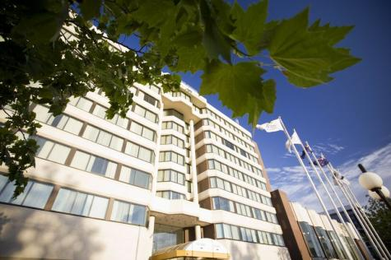

Contact information: The Sebel Albert Park
65 Queens Road
Melbourne VIC 3004 Australia
Phone: 61 3 9529 4300
Fax: 61 3 9521 3111
Website: http://www.mirvachotels.com/sebel-albert-park-melbourne?gclid=CIKslt732K8CFShLpgodmT0dAw

The Sebel Albert Park Hotel is ideally located opposite Albert Park Lake, home of Australian Grand Prix track.
- This modern hotel is minutes from the St Kilda Road business district and a short tram ride to Melbourne's CBD.
- With 242 modern guestrooms featuring king, queen and twin beds, The Sebel Albert Park Hotel is also one of Melbourne's largest conference and event venues.
- The Sebel Albert Park Melbourne hotel boasts facilities such as 24-hour reception, in-room dining and concierge, restaurant, cafe, bar, business centre, heated indoor pool, spa, gymnasium and ample parking onsite.

Albert Park Conference and Dining
The Sebel Albert Park is one of Melbourne's largest and most comprehensive conference and event venues.
Dining options at The Sebel Albert Park Melbourne include:
- Windows Restaurant offers an extensive a' la carte menu of modern Australian cuisine. Featuring a sensational Seafood Buffet every Friday and Saturday evening
- The Atrium Bar & Lounge showcases an extensive wine list, cocktail and snack menu, ideal for relaxing with friends and colleagues
- Cafe @ Sebel offers speciality teas, espresso coffees, bakery items, fresh salads, sandwiches and sweet treats

Air Travel Information & Transportation:

The Sebel Albert Park is approximately 20 minutes from the Tullamarine Airport by taxi.

Hotel Accommodations:
Guest rooms at the rate of $186 per night for 2 people are available at the Sebel Albert Park Hotel, with buffet breakfast included.
  - All Albert Park accommodation rooms feature:
    - LCD TV with satellite channels
    - Minibar
    - Laptop safe
    - Highspeed broadband
    - In-house movies
    - Individual climate control
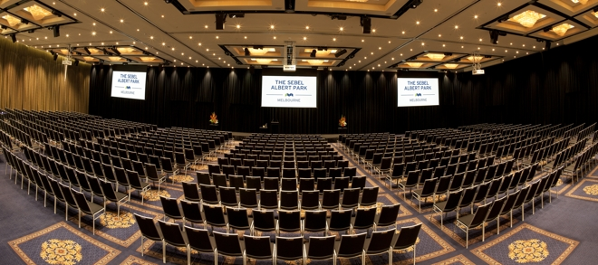
Destination: Melbourne, Victoria, Australia

Location:
Melbourne is located in the south-east of mainland Australia, within the state of Victoria. Melbourne is the capital and most populous city in the state of Victoria, and the second most populous city in Australia. As of June 2010, the greater geographical area had an approximate population of four million. Inhabitants of Melbourne are called Melbournians.

Often referred to as the "cultural capital of Australia, Melbourne is the birthplace of cultural institutions such as Australian film (as well as the world's first feature film).

Climate:
Melbourne has a moderate oceanic climate and is well known for its changeable weather conditions. This is mainly due to Melbourne's location situated on the boundary of the very hot inland areas and the cold southern ocean. This temperature differential is most pronounced in the spring and summer months and can cause very strong cold fronts to form. The average temperature in August will be about 15⁰C to 20⁰C.

Culture:
Melbourne is an international cultural centre, with cultural endeavours spanning major events and festivals, drama, musicals, comedy, music, art, architecture, literature, film and television.

Giới thiệu về Melbourne:

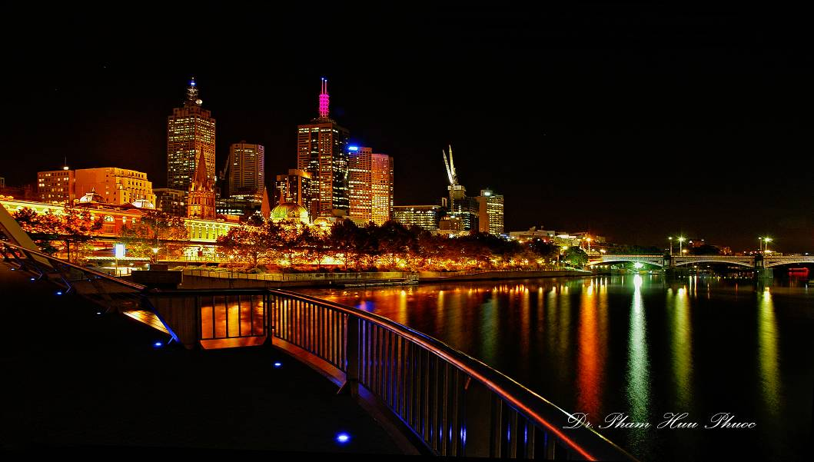
Melbourne by night
(Photo taken by Dr. Phuoc Huu Pham)

- Ngôn ngữ: Anh
- Tiền tệ: đô la Úc (AUD)
- Đổi tiền: http://www.ozforex.com.au/
- Thời tiết: Melbourne có 4 mùa. Nhiệt độ trung bình trong tháng Tám sẽ từ 15⁰C đến 20⁰C
- Credit Cards: các loại thẻ tín dụng đều được chấp nhận khi mua sắm . eps. VISA, Master cards
- Time Zone: standard timezone: GMT+10
Du khách ngoại quốc cần valid passport Visa or ETA. esp. www.immi.gov.au/e-visa/ visitor.htm

Cảnh quang Melbourne:
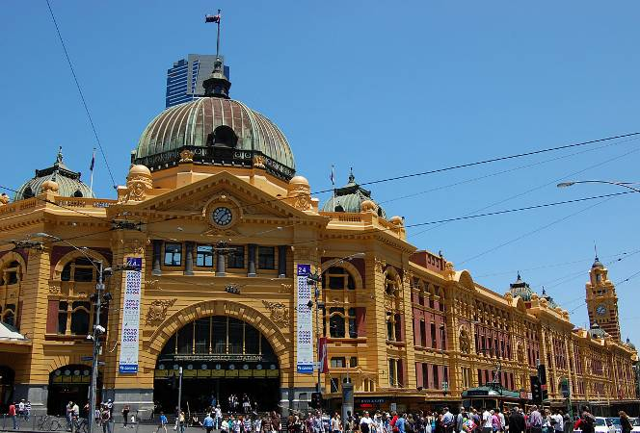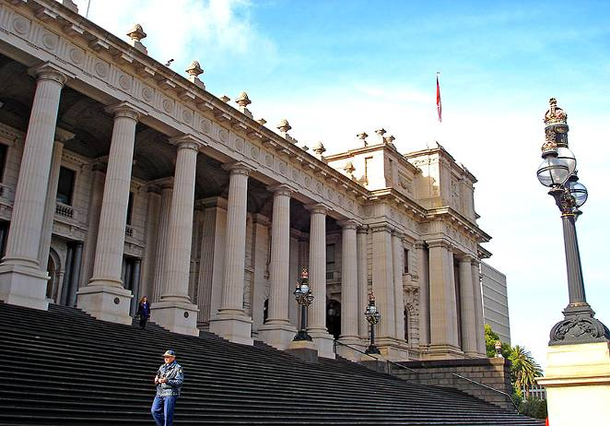
Flinder Street Station Paliament of Victoria
(Photo taken by Dr. Phuong Huu Pham) (Photo taken by Dr. Phuong Huu Pham)

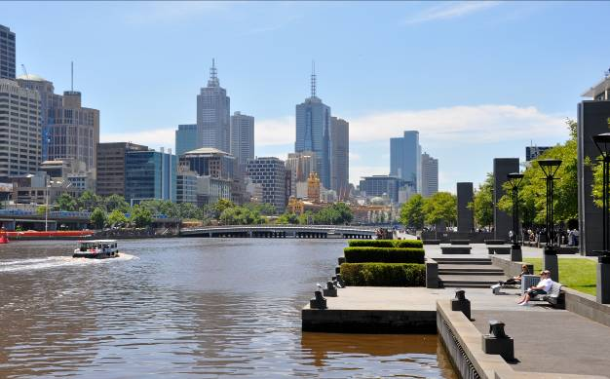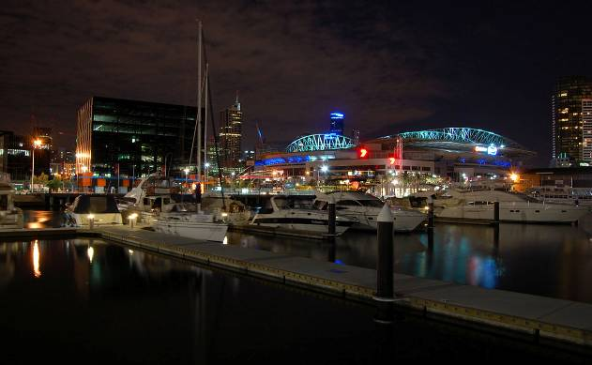
Yarra River Dockland at night
(Photo taken by Dr. Phuong Huu Pham) (Photo taken by Dr. Phuong Huu Pham)

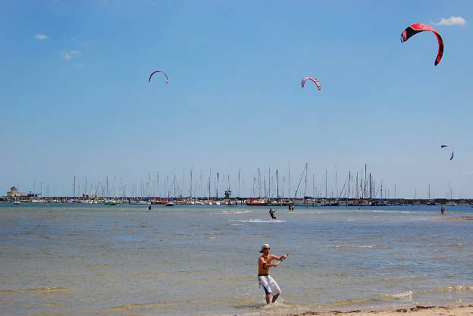
Williamstown beach
(Photo taken by Dr. Phuong Huu Pham)

Đi thăm thắng cảnh địa phương:
- Great Ocean Road nổi tiếng với 12 tảng đá khổng lồ hùng vĩ giữa biển khơi được bao bọc bởi khung cảnh thiên nhiên thơ mộng. Nơi đây sẽ là điểm dừng chân lý tưởng cho những du khách yêu chuộng thiên nhiên.

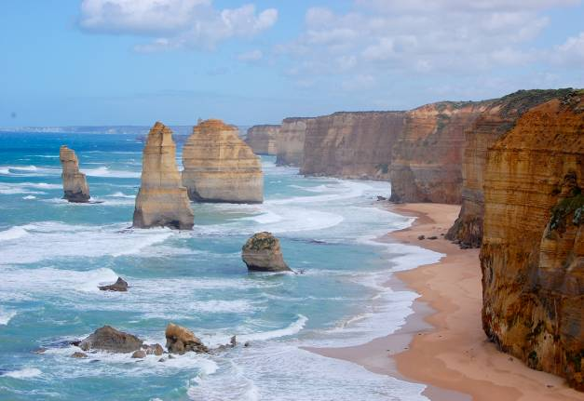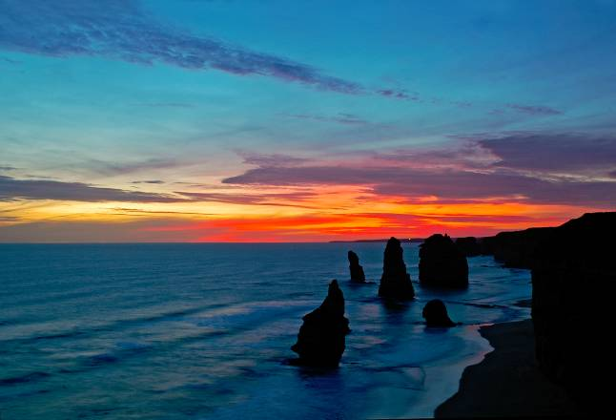
(Photo taken by Dr. Phuong Huu Pham) (Photo taken by Dr. Phuoc Huu Pham)

Mua sắm:
- 2 trong những trung tâm mua sắm lớn và thuận tiện cho việc đi lại tại Melbourne là Highpoint Shopping Centre và Melbourne Central Shopping Centre,Charpel street (South Yarra), Queen Victoria market,Collin street Melbourne,South gate Carsino,Bridge road Richmond.

Khu người việt:
- Tại Richmond, Footscray, Springvale, St. Albans… Đây là nhiều địa điểm tập trung đông đảo cộng đồng người Việt. Tại đây có những món ăn thuần túy Việt Nam như phở, bánh canh, bánh xèo, bánh cuốn, nem nướng, bún thịt nướng, chả giò, bánh mì…
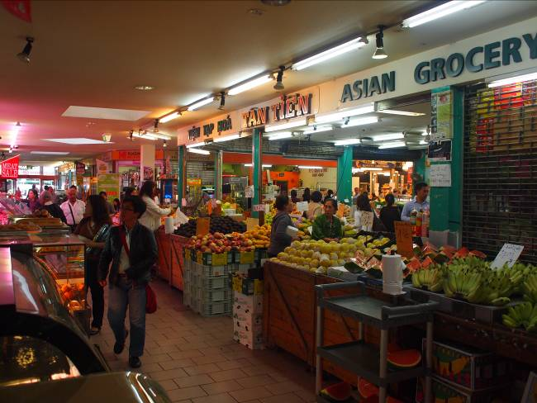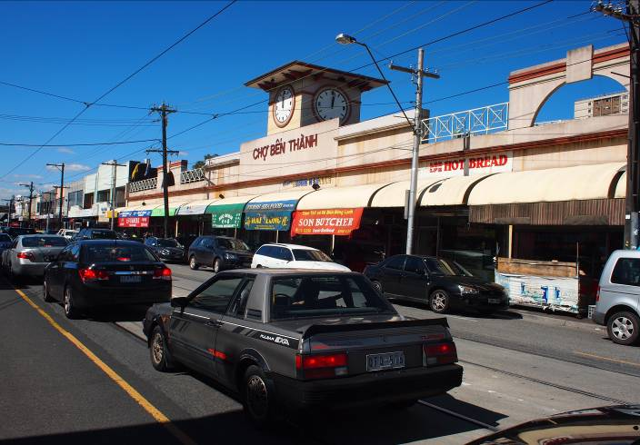
Bilo Market (Footscrsay) Ben Thanh Market (Richmond)
(Photo taken by Dr. Phuc Nhan Pham) (Photo taken by Dr. Phuc Nhan Pham)

Thêm những hình ảnh của Úc:
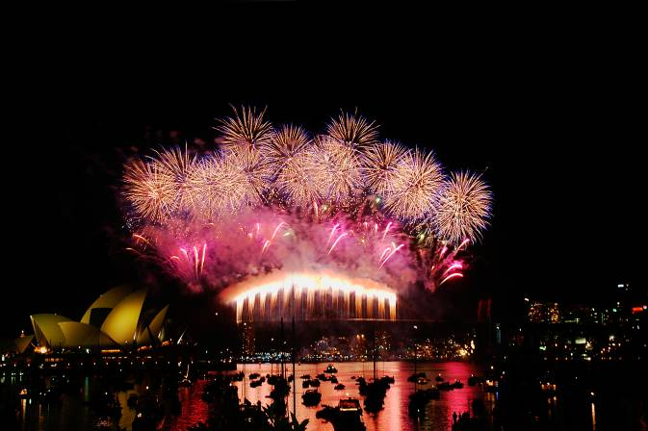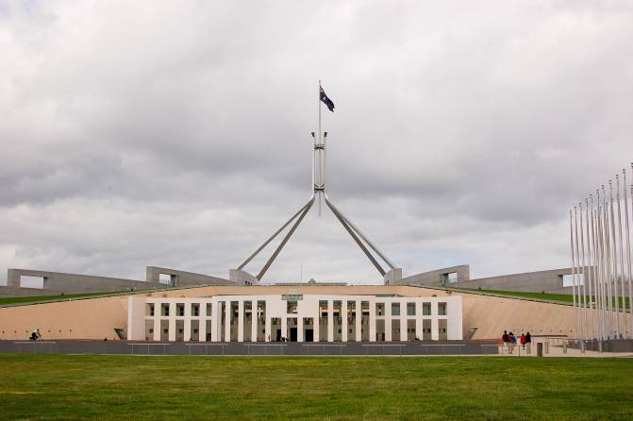
Firework near Sydney Opera House Canberra Paliament House
(Photo taken by Dr. Phuoc Huu Pham) (Photo taken by Dr. Phuong Huu Pham)

YND Melbourne Recommended Tour Operators:

- Mrs. Khánh Hoài:
  - Tel: 514 804 4346
  - Email: juliettehoai@gmail.com

- Dr. David Tăng Minh’s wife:

- YES tour : 218 Main Road East . St ALBANS VIC 3021
Tel 93560555 Mol 0423981417
Email: yestravel@bigpond.com

Đặc San Đại Hội
Chúng tôi rất cần các tác phẩm nghệ thuật văn chương và khoa học của các bạn, bao gồm: văn, thơ nhạc, truyện ngắn, hình ảnh nghệ thuật, văn hóa, xã hội, khoa học, tài liệu Y Nha Dược. Các bạn cũng có thể tham gia triển lãm tranh vẽ, ảnh nghệ thuật , tác phẩm báo ấn hành. Hạn chót nộp bài là 01/06/2014. Rất mong nhận được sự đóng góp hăng hái của các bạn để Đặc San Đại Hội của chúng ta được thêm phần phong phú.

Xin liên lạc Website Đại Hội để ghi danh.

Why attend YND Melbourne 2014?

- Join us for an accredited conference in Medicine, Dentistry and Pharmacy.

- An exceptional opportunity for professional networking and collegial collaboration.

- Celebrate Vietnamese & Australian heritage.

- Reunite with former classmates and meet new friends

- Dine, sing, dance during the unforgettable, non-stop entertainment Reunion Dinner and Gala Night, featuring Australian singer & Vietnamese Cai Luong artist.

- Bring your family to this tax-deductible conference ( not apply for spouse and family members) and explore the alluring Melbourne.

- Take advantage of the reduced rates, $186 for 2 people/night with free breakfast at the Sebel Albert Park Hotel.

- Curious about the Australian aborigines, giant desert, mighty forest, great barrier reef, Uluru, Alice Spring, koalas and kangaroos? Come see for yourself!

- Goods bought in Australian Airport to home is tax free.

REGISTRATION INSTRUCTIONS & COST:

Registering for YND Melbourne 2014 is easy. We offer 2 convenient methods of registration: online and mail. Register must be before 8 July 2014.

* Note: Due to some circumstances, The Sebel Albert Park Hotel is unable to cover the event fee, so accommodation free is separated from the event fee.

- For accommodation: on our website, there is a weblink to the hotel’s page, please click on and follow the instruction to proceed your payment to the hotel.

(If you find the booking through internet inconvenient, we also offer assistant. Please contact us through:
  - Email nhanphucpham@yahoo.com.au; or
  - Fax: (0011) - (61) - 3 - 9367 7910; or
  - Phone: (0011) - (61) - 3 - 9367 7923

- Event free: can be paid in 2 methods: by internet or by mail:

All prices listed are in Australian Currency | Registration, Traveling, Lunch, Reunion Night, Gala Night | Fee
Practicing Physicians, Dentists, Pharmacists | - City tour:  - Lunch: 20 different kinds of food  - Dinner: special seafood | $605
Non- Practicing Physicians, Dentists, Pharmacists | As above | $495
Spouse, Children, Guests | As above | $385

By Internet:
Step 1: Complete and submit the online register form (this form will be available on our association website)

Step 2: Transfer the money to our bank account:
********************Net banking account******************
(Payment through Paypal is strongly recommended, we will not take responsibility for any loss if using direct bank transfer)

Step 3: You will receive a confirmation notification through email once payment and the application have been processed (confirmation notification may take 1-2 days, after the money is received, to proceed)

By Mail:
Step 1: Print out and complete the registration form (this form will be available on our association website)

Step 2: Prepare payment:
Payment by cheque is accepted for delegates regarding within Australia. Payment by bank draft or money order in Australian dollars (AUD) or in US dollars (USD) is accepted at par for the delegates residing outside of Australia.

Please choose one of the following methods:

- Using cheque, bank draft or money order payable to:

ST. ALBANS FAMILY DOCTOR CLINIC
  - 165 St. Albans Road - St. Albans Vic 3021 - Melbourne, Australia
  - Phone: (61) - 3 - 9367 7923
  - Fax: (61) - 3 - 9367 7901 Email nhanphucpham@yahoo.com.au

- Or, Direct International Money Transfer is also available:
- Bank: Commonwealth Bank of Australia
- Bank address: 80 Nicholson St - Footscray - Vic - 3011
- BSB / Account Number: 06 3132 1059 2881
- BIC/ SWIFT CODE: CTBAAU2S
- Account Name: The AVHPA of Vic
Step 3: Send the register form to us via either:
- Fax: (+61) (03) 9367 7901
- Email: nhanphucpham@yahoo.com.au (please scan the attachment)
- Or send it along with your cheque/ money order to ST. ALBANS FAMILY DOCTOR CLINIC

Step 4: You will receive a confirmation notification through email once payment and the application form have been received (confirmation notification may take 1-2 days to proceed)

* Note:
- Once again, accommodation and event are proceeded separately. Therefore, a registration form is required even though you have already filled out the details on the hotel’s weblink.
- Please regard to the hotel’s weblink for appropriate payment and send us the Event Fee and registration for.
- All prices are listed in Australian Dollars (AUD)
- Certificate of attending will be issued only to those who attend the meeting.

We apologise for any inconvenience

Cancellation & Refund Policy:
In order to qualify for a refund of fees, cancellation notice must be received in writing (letter or email) no later than 8th July 2014. There will be no refund of fees for cancellation received after that date. Registration fees will be refunded after the convention.

YND MELBOURNE 2014 REGISTRATION FORM
Registration Category | Physician Dentist Pharmacist Student/Resident/ Fellow
Registration Category | Retired or inactive? No Yes Medicine Dentistry Pharmacy
 | Dr. Prof Mr. Mrs. Ms. Miss | Gender: M F

Family Name: | Middle Name: | First Name:
Address Line 1:

Address Line 2: |  |  | City:
Country: | State/ Province: |  | Zip / Postal Code:
Phone: | Mobile: |  | Fax:
Email:

Specialty: | University/Hospital Affiliation:
School Graduated: |  | Year Graduated:
Emergency contact: |  | Relationship to applicant:
Phone 1: | Phone 2:

Spouse /Guest(s) / Children Information | Complete this session if accompanying spouse / guest(s) is also a health care professional. They must register separately. This section is used for internal administrative purpose
Family Name: | Middle Name: | First Name:
Physician Dentist Pharmacist Student/Resident/ Fellow |  | Registration No.:
Complete this section for accompanying spouse / guest(s) / children:
No. | Family Name | Middle Name | First Name | Relationship
1
2
3
4
Special request (ie.Group seating, special diet, etc…) Note: We will try our best but cannot guarantee to honour all of them:
YND Melbourne 2014 Contact Information

Medicine: Dentistry

Dr. Pham Phuc Nhan Dr. Pham Hong Duc
165 St. Albans Road St Albans Vic 3021 34 Leeds St Footscray Vic 3011
Phone: (0011)-(61)-3-9367 7923 Phone: (0011) -(61)–3-9687 7933
Email: nhanphucpham@yahoo.com.au Email: dcsmile_clinic@yahoo.com.au

Dr. Pham Sy Lieu Pharmacy
34 Leeds St Footscray Vic 3011 Pharmacist Tran Hai
Phone: (0011)-(61)-3-9687 7933 548 Murray Rd Preston West Vic 3072
Email: lieupham07@gmail.com Phone: (0011)-(61)-3-9470 3083
Email: prestonpharmacy@yahoo.com.au

Chair:
Dr. Pham Phuc Nhan

Vice Chair:
Dr. Pham Sy Lieu
Dr. Nguyen Tin
Dr. Pham Hong Duc
Dr. Tran Minh Tuong Le
Pharmacist Tran Hai
Pharmacist Le Phong

Số giờ huấn luyện chuyên môn trong 2 ngay:
Y + Nha + Duoc: Tham Dự Viên sẽ được cấp 40 diem (Loai 1) CPD
~~~~~~~~~~~~~~~~~~~~~~~

CPD Points for attending the educational meeting in 2 days:
Medicine + Dentistry + Pharmacy: Attendants will be awarded with 40 (Category 1) CPD

Organizers:

Under the auspices of:
- The Association of the Vietnamese Physicians, Dentists and Pharmacists of The Free World

Local Organizing Committee:
  - The Vietnamese Australian Medical Dental & Pharmaceutical Association of Australia
  - The Vietnamese Australian Health Professionals Association of Victoria

